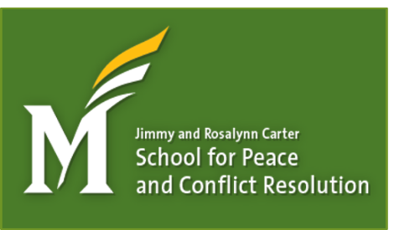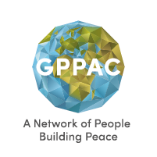

9th International Virtual College and University Seminar:
Developing and Enhancing Peace and Conflict Studies Programs
March 22, 2021 – April 16, 2021
Call for Proposals/Applications

(Deadline to submit a proposal/application to present and/or participate is February 26th. All applicants will be notified by March 3rd if your application is accepted for participation).

College/University faculty/staff/administrators will develop action plans during the event as they focus on one or more of the three tracks (1) Capacity Building and Sustainability of Programs; (2) Course Development/Integration; (3) Supplemental Programming.

Name:
Role at College/University:
College/University:
Web site link(s) to your college/university peace or conflict study program(s):
Email:
Please include a short bio of up to 250 words:

General Questions
- What interests you about the seminar? What do you hope to accomplish as a result?
- Do you have a degree in peace or conflict resolution from a college or university? If so, what is it and from which college or university?

Course Development/Integration
- Do you have any classroom management strategies you use in the classroom specific to conflict resolution or peace education strategies?
- Do you currently teach a course(s) in peace or conflict resolution?
- What resource(s) do you use to teach the content in your courses that you find most helpful.
- What technology do you use in the classroom/with your programs?
- Do you have transfer agreements with other colleges/universities for your courses in peace and conflict resolution?
- What information related to course development and integration would you like to learn more about specifically?
- What do you think your college/university does really well in the area of course development and integration?
Supplemental Programming
- Do you oversee any student programming related to peace and conflict resolution?
- Do you offer any study abroad for students related to peace and conflict resolution?
- Do you offer any international faculty/staff/administrator study abroad related to peace and conflict resolution?
- What information related to supplemental programming would you like to learn more about specifically?
- What do you think your college/university does really well in the area of supplemental programming?

Capacity Building and Sustainability of Programs
- Does your peace and conflict resolution program mission match with your college’s mission statement?
- Does your peace and conflict resolution program link to your college/university strategic plans?
- Does your peace and conflict resolution program link to your college/university general education outcomes
- How have you marketed your program, courses, etc.?
- Do your program(s) have administrative support w/in your college or university?
- What professional development is offered to faculty/staff/students/community members related to conflict resolution and peace studies at your college/university?
- How do you prepare faculty without a background in the field to teach related course content in this field?
- Do you include as a requirement or preference in your hiring of new faculty/staff/administrators a question related to their education/knowledge/or experience in Conflict Resolution/Peace Education?
- What information related to capacity building and sustainability of programs would you like to learn more about specifically?
- What do you think your college/university does really well in the area of capacity building and sustainability of programs?
- Does your college/university undertake any formal assessment and/or evaluation of your existing Conflict Resolution/Peace Education/Peace Studies programs?

Your participation on the Agenda
- What areas, based on the questions above, do you feel that you have the most experience with?
- Is there something innovative/new that you would like to be sure to share with the rest of the participants related to peace and conflict resolution in higher education that either you are working on and/or know about?
- Is there anything else you’d like us to know or consider as we plan the agenda?

Questions? Contact Jennifer Batton, Coordinator, Ohio Peace and Conflict Studies Network, by email at Ohiopcsn@gmail.com or by phone, +1-216-952-5609 (U.S. – Eastern Time Zone)

Please submit your proposal by February 26th to Ohiopcsn@gmail.com

